Experiential Learning Theory

General
Experiential learning theory is a cycle learning theory introduced by American educational theorist David Kolb1) in 19712) and was inspired by earlier works of Kurt Lewin, Jean Piaget3) and John Dewey. As it was developed within humanist paradigm, experiential learning offers a holistic perspective on learning and is orientated mostly on adult learning. Name of this theory was intended to should emphasize the importance of experience in the learning process.
Experiential learning theory defines learning as
- “the process whereby knowledge is created through the transformation of experience. Knowledge results from the combination of grasping and transforming experience.”4)

What is experiential learning?
The experiential learning theory is based on six propositions5) short described with the following three:
- Learning is best described as a holistic process of creating knowledge and adapting to the world.
- Learning is actually relearning, since it is greatly dependent on already learned material.
- Learning is driven by conflict, differences, and disagreement and results in assimilation and accommodation.
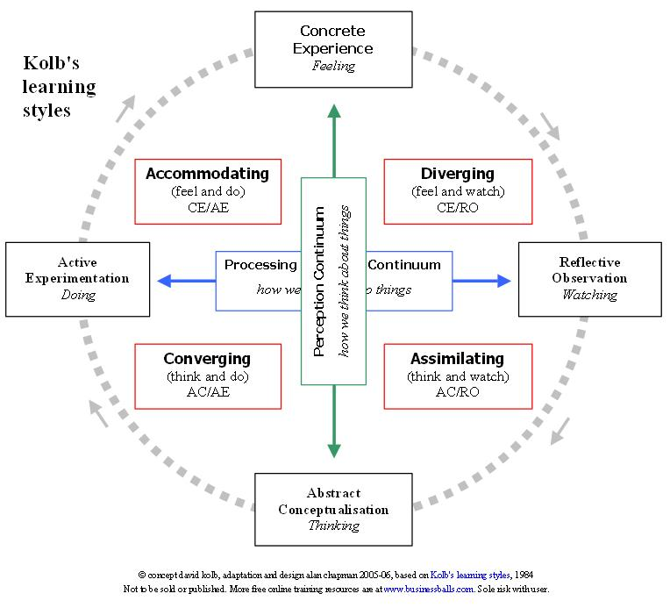Kolb's original four learning styles and stages. Image borrowed from: http://www.businessballs.com/... Click on the picture to follow the link.
Kolb5) suggests two opposite modes of acquiring experience:
- concrete experience or CE (feeling through practical experiencing),
- abstract conceptualization or AC (concluding and thinking about the experience),
and two opposite modes of transforming that experience into knowledge:
- reflective observation or RO (actively observing experience and its outcomes),
- active experimentation or AE (planing on how to test something and finally doing).
All of these components together form a circle of learning in which they follow one after another: CE->RO->AC->AE->CE->... The very process of learning can begin in any of them. Still, every learner develops strengths in some of mentioned modes more than in others and learn better under those conditions, which results in four different learning styles identified also by Kolb6)5):
- Assimilator - Strong in AC and RO components. Prefers abstract conceptualizations and theoretical models, requires time to think through. Values logical validity more than practical applications.
- Converger - Strong in AC and AE components. Prefers practical applications of concepts and theories he learns and like experimenting. They are often good problem solvers and like dealing with technical issues.
- Accommodator - Strong in CE and AE components. Prefers practical experiences and acting more according to the feeling than based on logical analysis or theoretical aspects.
- Diverger - Strong in CE and RO modes. Prefers learning through observing and collecting information, good at viewing concrete situations from different points of view. This kind of people are often imaginative and emotional, and often specialize in arts.7)
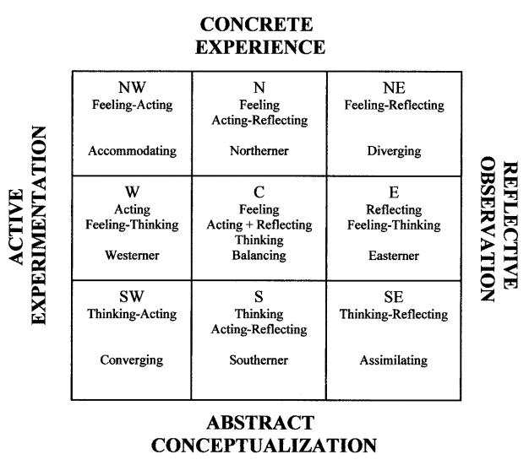The new 9 learning styles. Notice how the old learning styles now form the corners of the rectangle. Image borrowed from: Kolb, D A. Learning Styles and Learning Spaces: Enhancing Experiential Learning in Higher Education. Click on the picture to follow the link.
Kolb's model was later refined by himself and other researchers8)9)10) through improvement of the learning styles grid resolution from 2×2 to 3×3 by introducing five additional learning styles5):
- Northerner - Strong in CE and balanced in AE and RO modes. Has a capacity for deep involvement and learns through experimenting, but has problems with conceptualizations.
- Westerner - Strong in AE and balanced in CE and AC modes. Has great action skills and possibilities for thinking and conceptualizing, but problems with analyzing past experience.
- Easterner - Strong in RO and balanced in CE and AC modes. Has great observation and reflection skills as well as learning from concrete experience, but problems with putting his plans into action.
- Southerner - Strong in AC and balanced in AE and RO modes. Has great conceptualization skills, but little use of practical experiences.
- Balancing - Evenly balancing both modes of acquiring experience and both modes of transforming that experience into knowledge.
In order to identify preferred learning style in Kolb's model, “learning style inventory” method has been developed. This method for determining an individual’s optimal learning style, strengths and weaknesses consists of a survey which explores one's perceiving (how one prefers to acquire information) and processing (how one makes sense of new things). Various variants of this method can be found in simplified free on-line tests11) and newer methods like the adaptive style inventory or the learning skills profile have also been introduced12).

What is the practical meaning of experiential learning?
Experiential learning is a model suggested for adult learners. General implications of this model are that teaching/learning process should consist of all four stages of Kolb's model, but it also suggests individual changes should be applied, depending on learners learning style.
- Assimilators - prefer watching, thinking and good explanations of theories and ideas to practical experiences. This kind of learners usually enjoy lectures and readings as well as having enough time to think about new ideas.
- Convergers - prefer doing and thinking, finding practical solutions to problems. This kind of learners usually like new ideas and their practical applications.
- Accomodators - prefer practical experiences and intuitive approach instead of reading instructions. This kind of learners also usually prefer teamwork.
- Divergers - prefer watching, collecting information, working in groups and brainstorm instead of having practical experience.
Kolb's theory was applied in a number of studies on topics that include (online) education, computer and information science, psychology, management, medicine, nursing, accounting and law.13)14)15) It has also influenced other authors to create similar models for determining of preferred learning style. The critique that Kolb's learning styles inventory was difficult to apply to people who never really paid attention to how they learn more efficiently encouraged Peter Honey and Alan Mumford to create their Learning Styles Questionnaire16). It was based on Kolb's theory, but instead of asking people how they learn it was probing for most common learning behaviors. Other similar models include: Anthony Gregorc's Mind Styles Model17)

Criticisms
Some of the criticisms18) referring to Kolb's theory include19):
- doubts that not everyone's learning process has to undergo Kolb's stages and not necessarily in that order,
- lack of experimental research and too simplified learning cycle which ignores non-experiential learning, and
- not paying enough attention to the process of reflection and lack of precision.

Keywords and most important names
- Concrete experience (CE), reflective observation (RO), abstract conceptualization (AC), active experimentation (AE), assimilator, converger, accomodator, diverger, learning style inventory, learning styles, northerner, westerner, easterner, southerner, balancing
- David Kolb

Bibliography
Kolb, D. A, R. E Boyatzis, and C. Mainemelis. Experiential learning theory: Previous research and new directions. Perspectives on thinking, learning, and cognitive styles. The educational psychology series: 227–247. 2001.
Experiential Learning (Kolb) at Learning Theories. Retrieved February 9, 2011.
TIP: Theories. Experiential Learning. Retrieved February 8, 2011.
Greenaway, R. Experiential Learning articles and critiques of David Kolb's theory. Retrieved March 21, 2011.
Lowy, Alex, and Phil Hood. The power of the 2x2 matrix: using 2x2 thinking to solve business problems and make better decisions. John Wiley and Sons, 2004.
Big Dog and Little Dog's Performance Juxtaposition: Honey and Mumford's Learning Styles Questionnaire. Retrieved February 8, 2011.

Read more
Kolb, David A. Experiential Learning: Experience as the Source of Learning and Development. Prentice-Hall, Inc., Englewood Cliffs, N.J. 1984.
Kolb, David A. Learning style inventory. Boston, MA: McBer and Company. 1985.
Kolb, D. A, R. E Boyatzis, and Mainemelis, C. Experiential learning theory: Previous research and new directions. Perspectives on thinking, learning, and cognitive styles: p227–247. 2001.

1) Some sources like Cooper, S. Theories of Learning in Educational Psychology or Kearsley G. Explorations in Learning & Instruction: The Theory Into Practice Database associate experiential learning with Carl Rogers.
2) Kolb, D. A. Individual learning styles and the learning process. Cambridge, MA: Massachusetts Institute of Technology, 1971.
3) See also: Stage Theory of Cognitive Development
4) Kolb, David A. Experiential learning: experience as the source of learning and development. Prentice-Hall, 1984.
5) Kolb, Alice Y., and David A. Kolb. Learning Styles and Learning Spaces : Enhancing Experiential Learning in Higher Education. Academy of Management Learning Education 4, no. 2: 193-212, 2005.
6) Kolb, David A. Experiential learning: experience as the source of learning and development. Prentice-Hall, 1984.
7) Kolb, D. A, R. E Boyatzis, and C. Mainemelis. Experiential learning theory: Previous research and new directions. Perspectives on thinking, learning, and cognitive styles. The educational psychology series: 227–247. 2001.
8) Abbey, David S., David E. Hunt, and John C. Weiser. Variations on a Theme by Kolb. The Counseling Psychologist 13, no. 3: 477 -501, 1985.
9) Hunt, David Ellis. Beginning with ourselves in practice, theory, and human affairs. Brookline Books, 1987.
10) Mainemelis, Charalampos, Richard E. Boyatzis, and David A. Kolb. Learning Styles and Adaptive Flexibility. Management Learning 33, no. 1: 5-33, March 2002.
11) For example: Duncan, D. Kolb Learning Style Inventory. University of Colorado at Boulder.
12) Mainemelis, Charalampos, Richard E. Boyatzis, and David A. Kolb. Learning Styles and Adaptive Flexibility. Management Learning 33, no. 1: 5 -33, March 2002.
13) Kolb, D. A, R. E Boyatzis, and C. Mainemelis. Experiential learning theory: Previous research and new directions. Perspectives on thinking, learning, and cognitive styles. The educational psychology series: 227–247, 2001.
14) Kolb, D A. Learning Styles and Learning Spaces : Enhancing Experiential Learning in Higher Education. Academy of Management Learning Education 4, no. 2: 193-212. 2005.
15) Richmond, A. S, and R. Cummings. Implementing Kolb’s learning styles into online distance education. International Journal of Technology in Teaching and Learning 1, no. 1: 45–54, 2005.
16) Honey & Mumford Learning Styles Questionnaire (LSQ)
17) The Mind Styles Model: Theory, Principles, and Applications. AFG, 2006.
18) Greenaway, R. Experiential Learning articles and critiques of David Kolb's theory
19) Forrest, C. Kolb's Learning Cycle. Train the Trainer. Issue 12, 2004.

