The Spatial Contiguity Principle

Theory

Practice
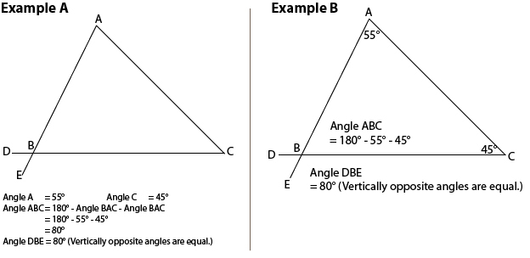Spatial contiguity principle. Image borrowed from: http://eet.sdsu.edu/eetwiki... Click on the picture to follow the link.

Research status

