Worked Examples Effects

Theory
The worked examples effect was first introduced in 19851) suggesting positive effects of providing a learner with an example of the problem solution before requiring him to solve one on his own.
This suggestion is contrary to many constructivist discovery learning methods which suggest a learner should try to solve the problem by himself. Cognitive load theory on the other hand suggests that searching for the problem solution places unnecessary load on the learner's mind preventing him from learning. A worked example will remove the load of searching for a solution and enable easier acquisition of basic steps leading to the solution.

Practice
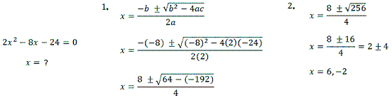
Learners should be presented with a worked example of the procedure they're expected to learn prior to trying to solving a problem which requires that procedure. For example, when teaching learners the formula for calculating roots of a quadratic formula, learners should first be provided with a worked example of using the formula, and then try to solve a problem on their own.

Research status

1) Sweller, John, and Graham Cooper. The Use of Worked Examples as a Substitute for Problem Solving in Learning Algebra. Cognition and Instruction 2: 59-89, 1985.

